Which Door Is It?
10-Meters at K3LR for ARRL DX CW
Carl Luetzelschwab K9LA

On Friday evening, 10-Meters wasn’t very productive to SE Asia and JA at Tim Duffy’s K3LR Multi-Multi station. Only a handful of stations were worked Friday evening on 10-Meters, with only one being from that area (JA1BPA)
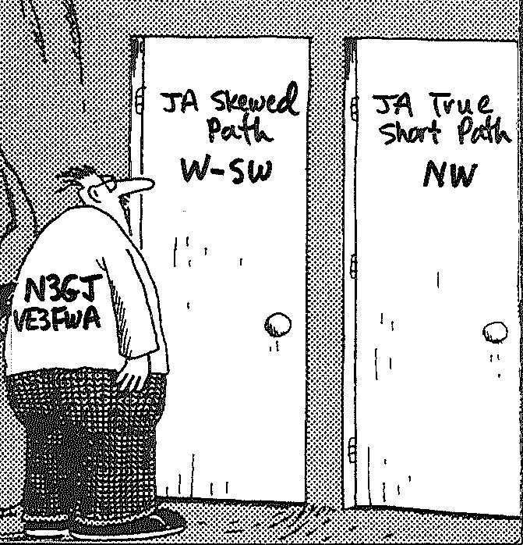

Saturday night was a different story. George Gross N3GJ and Ed Kulchenko VE3FWA, the 10-Meter ops at K3LR, began working JAs around 2200 UTC, but the path was not the true great circle short path to the northwest – it was a skewed path to the west-southwest (not an uncommon path). Later in the evening, beginning around 0130 UTC, more JAs and SE Asians were worked but now they were along the true short path. Why wasn’t the true great circle short path open initially? Why was the skewed path open? And why did the path shift back to the true great circle short path later in the evening?

As one might expect, all of this was tied to geomagnetic field activity. Figure 1 shows the high latitude K indices from February 12 thru February 19.

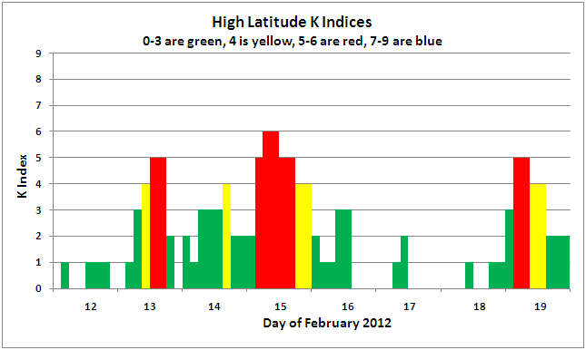
Figure 1 – High Latitude K Indices

From the 10th (not shown) thru the 12th the K index was 2 or below, indicating quiet geomagnetic field conditions. On the 13th the K index spiked up to 5, then settled back down until the 15th. Early on the 15th the geomagnetic field was very disturbed. It then again settled down until late on the 19th (right at the end of the Contest). Let’s look at ionosonde data to see how this affected the F₂ region of the high latitude and equatorial ionosphere on these paths from K3LR to SE Asia and JA. But first we’ll look at great circle paths out of K3LR.

Figure 2 shows great circle paths from K3LR, with the true great circle short path to JA highlighted in red. Fortunately there are two ionosondes near the K3LR-to-JA true great circle short path (this is unusual, as most of the time there isn’t an ionosonde close by the path, which really makes it tough to make any conclusions). The Gakona (Alaska) ionosonde is very near the path. The King Salmon (Alaska) ionosonde is also close to the path, but not as close as the Gakona ionosonde. The dotted line is the magnetic equator.

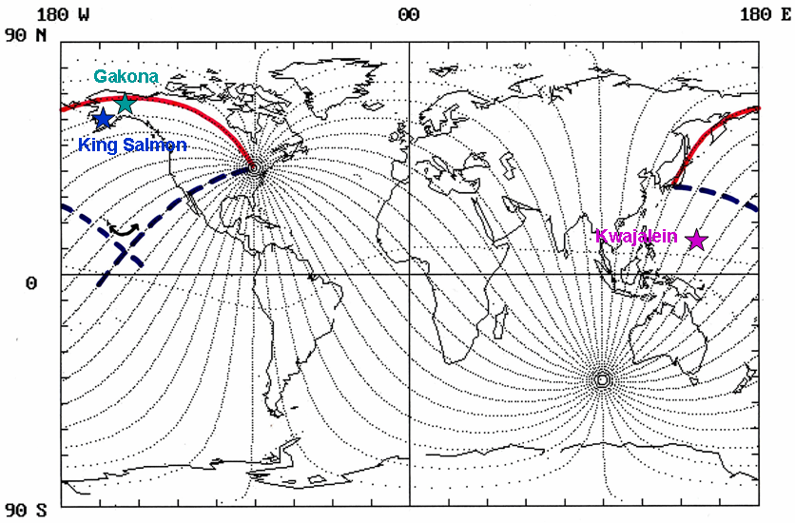
Figure 2 Great Circle Paths Out of K3LR

Also shown in Figure 2 is a west-southwest path out of K3LR, and an easterly path out of JA. Both are highlighted as dashed dark blue lines. This represents a possible skewed path observed by the K3LR ops earlier Saturday evening. The alleged skew point (where refraction, reflection, or scatter occurs to divert the electromagnetic wave off the great circle path out of K3LR and onto the great circle path into JA) is in the Pacific Ocean (more on this later). Now let’s look at the Gakona ionosonde data, which is Figure 3.

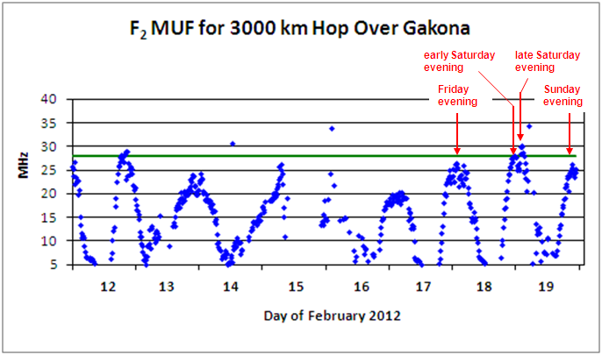
Figure 3 – Gakona Data

The ionosonde data gives us a good picture of what happened on Friday, Saturday, and Sunday evening of the Contest. The geomagnetic field activity on the 15th took its toll on high latitude F₂ region ionization. There were gaps in the data on the 15th, and this also resulted in significantly depressed electron densities on the 16th and 17th. The F₂ region began to recover on the 18th, but it didn’t recover enough for good solid 10-Meter propagation on Friday evening (the green solid line in Figure 3 is 28 MHz). The F₂ region continued its recovery on the 19th. Early Saturday evening the F₂ MUF (maximum useable frequency) appeared to peak just below 10-Meters. This is why the true great circle short path was not open initially.

But then the F₂ MUF showed a nice increase later Saturday evening, which allowed the true great circle short path to open. Then came the geomagnetic field activity early on the 19th, and it kept the F₂ MUF along the true great circle short path below 28 MHz Sunday evening (K3LR did work some SE Asia and JAs Sunday evening, but it was again via the west-southwest skewed path – the Friday evening JA was also via this skewed path). For the record, the King Salmon ionosonde showed similar trends as the Gakona ionosonde.

We’ve seen what happened along the true great circle short path and understand why it wasn’t available until later in the evening on Saturday, so now let’s try to look at the west-southwest skewed path. In Figure 2, the Kwajalein ionosonde is the closest to the alleged skew point. It’s still pretty far away, but it’s all we have out in the Pacific in that area. Unfortunately we run into a brick wall here. There is Kwajalein data up thru most of February 13, but then nothing. I even checked the ionograms (from whence the tabular data comes). Unless this data shows up, all we can do is speculate why the west-southwest path was there.

A clue comes from N3GJ. In a personal e-mail he said “The stronger signals were during the 0200z short path opening on Saturday night.” This tells us the skewed path was likely a lossy scatter mechanism at the skew point, not refraction (as on the true great circle short path) or reflection. That kind of makes sense, as the electron density and its gradient at the skew point would have to be pretty high and extensive to reflect or refract a 28 MHz electromagnetic wave by 90 degrees (refer back to Figure 2).

Now the area of the ionosphere at the alleged skew point is around the northern crest of the equatorial ionosphere (from 10 to 15 degrees north of the magnetic equator) and as such could have a high electron density. But my guess is the electron density wasn’t high enough (the Kwajalein ionosonde data might have confirmed or refuted this), and scatter was indeed the mechanism. Another possible scatter mechanism is sea scatter from high waves. Silberstein and Dickson (IEEE Transactions on Antennas & Propagation, January 1965) had a very interesting paper titled “Great-Circle and Deviated-Path Observations on CW Signals Using a Simple Technique” discussing this. Contact K9LA (k9la@arrl.net) for more information on this paper.

In summary, Saturday evening was an exciting time for the 10-Meter ops at K3LR. They had to make sure they ‘opened’ both doors to work SE Asia and JA. Finally, thanks to the K3LR crew for their helpful inputs on these events.

